* Different types for storage options are
  + SQL Databases
  + Azure Cosmos DB
  + Storage Accounts. <https://docs.microsoft.com/en-us/azure/storage/common/storage-account-overview>
* Storage account is attached to a resource group which has to be unique for a region. 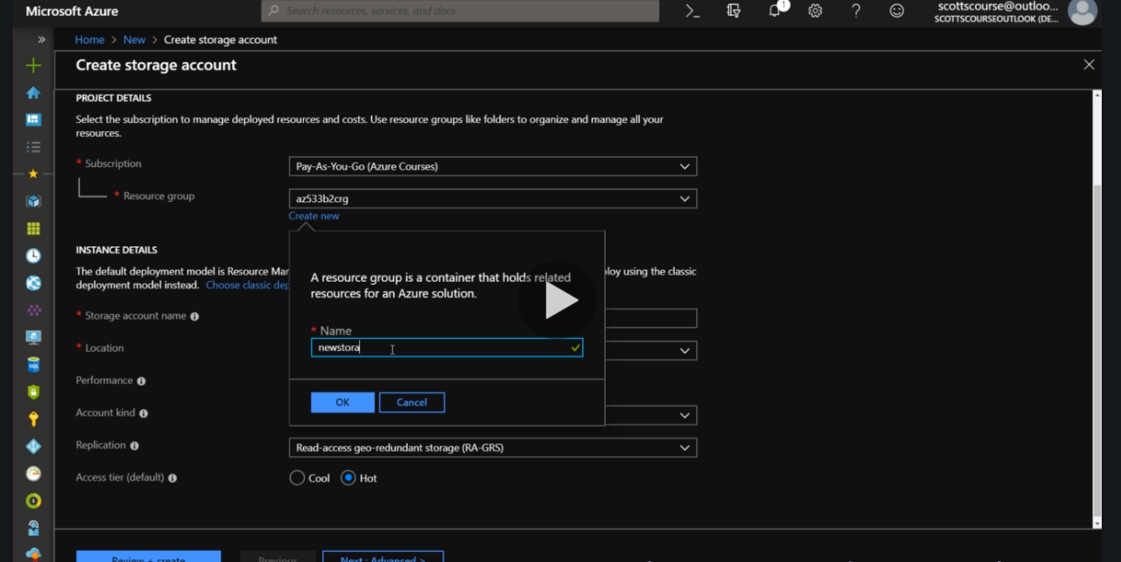
* Keep your application and files near to the user base.
* Performace of storage account is Important.
* StorageV2 is most advisable by azure. V1 is economical.
* Types for Geo replication 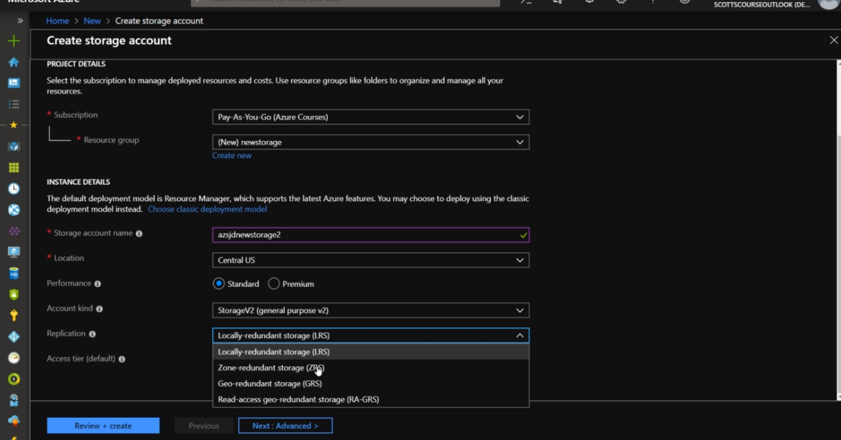
* Advanced Security tab 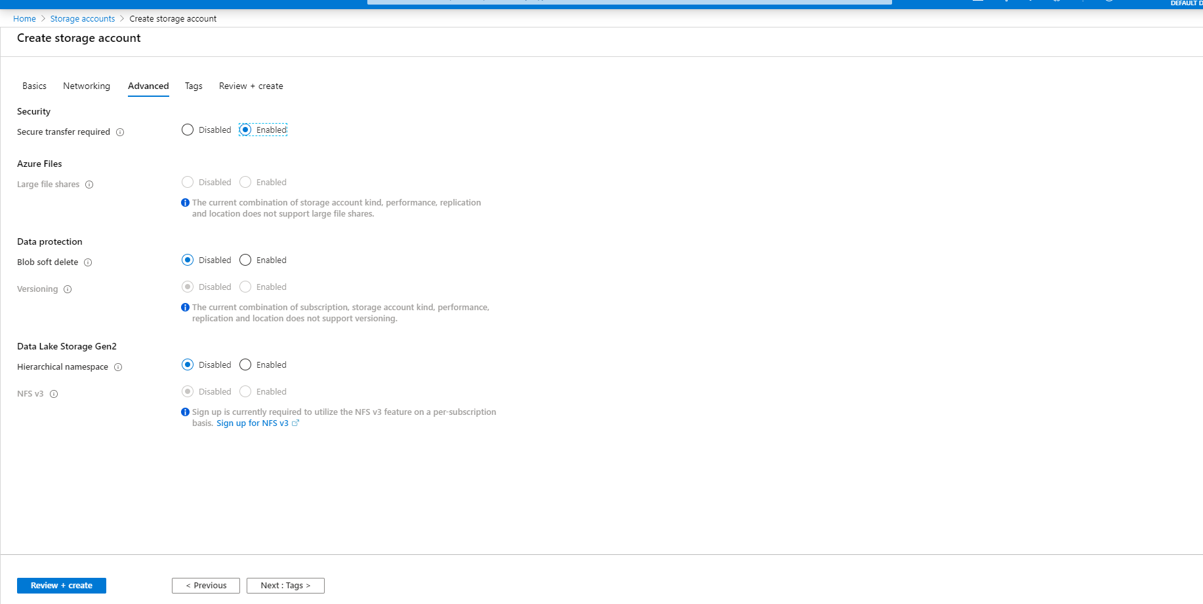
* 4 Service in a standard Storage Accounts. 